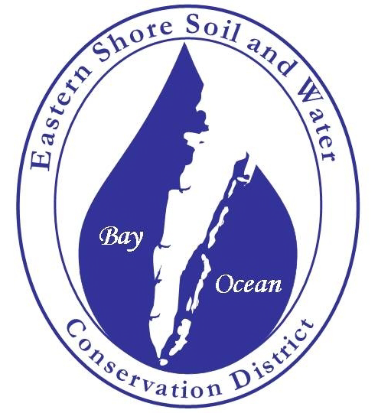

Annual Plan of Work

FY2024 (7/01/23 – 6/30/24)

Eastern Shore Soil and Water Conservation District
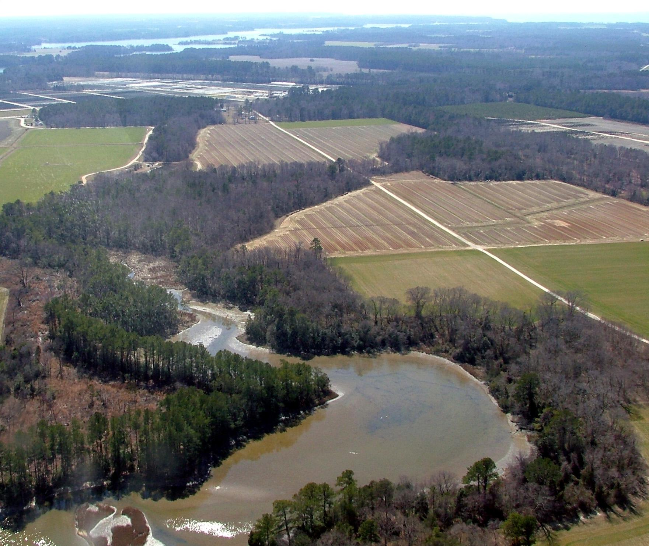

Serving: Accomack and Northampton Counties, Virginia

22545 Center Parkway, Accomac, VA 23301
Phone (757) 302-4431
For more information contact:
District Manager, Carmie M. Savage

Operations Committee Review Date: _______________________________
District Board Approval Date: _____________________________________
Signature of District Board Chair: __________________________________

The Eastern Shore Soil and Water Conservation District (Eastern Shore SWCD) is a political subdivision of the Commonwealth as defined and established by the § Code of Virginia, Title 10.1, Chapter 5, et seq. The Commonwealth of Virginia supports the Eastern Shore SWCD through financial and administrative assistance provided by the VA Soil and Water Conservation Board and the Department of Conservation and Recreation.

Mission – To provide and develop leadership in natural resource conservation on the Eastern Shore of Virginia through education, promotion of cooperative programs, and fulfillment of a diverse clientele’s needs.

Our Vision – The Eastern Shore Soil and Water Conservation District is the lead organization that provides intra-agency coordination in natural resource conservation to solve conservation problems effectively while protecting the resources, the public and the people whose livelihoods are dependent upon the use of natural resources. Where resource conflicts occur, the District will strive to produce technical and educational assistance and the leadership to develop consensus among all parties involved.

Natural Resource Priorities and Goals
- To lessen the impact of non-point source pollution on water quality.
- To conserve the natural resource base including wetlands, groundwater, wildlife habitat and prime farm lands through land-use policy and project implementation.

Information & Education Goals
- Carry out an active information and education program aimed at the general public, landowners, growers and schools to promote the District’s natural resource priorities.

District Operations Goals
- Conduct effective and efficient operations including accounting, grant administration and assessments, personnel management, training and development, annual planning and reporting.

Funding Sources
- The Commonwealth of VA supports the Eastern Shore SWCD through financial and administrative assistance provided by the VA Soil and Water Conservation Board and the Department of Conservation and Recreation (DCR). Accomack and Northampton Counties also provide financial support to the District.

The work of the District is determined by Directors, elected by the people of the District at general elections, by popular vote or appointed by the Virginia Soil and Water Conservation Board. These directors serve four-year terms and appoint (non-voting) associate directors for one-year terms to assist with District efforts. Directors and Associate Directors are volunteer public servants with a diverse range of knowledge and a keen interest in soil and water resource conservation.

Board of Directors
Nick Thomas, Chair
James Evans, Vice-Chair
Kyle Sturgis
vacant, VCE agent
Sands Gayle
Sally Williams

Associate Directors
Robbie Lewis
Edwin R. Long
Richard F. Hall, III
Chip Turlington
Hunter Blake
Norman Pitt
Matt Hickman
Brian Broadwater

Staff
Carmie M. Savage, District Manager,
and Board Secretary/ Treasurer
Julie Head, Education Director
Bill Savage, Conservation Specialist
Palmer Smith, Conservation Technician

Operations Committee
Nick Thomas, Chair
Carmie M. Savage, Secretary
Richard F. Hall, III
Olivia Leatherwood, DCR CDC

Endowment Committee
Carmie M. Savage, Secretary
Julie Head
Frank Moore
Rikki Sterrett
Sally Williams

Technical Committee
Richard F. Hall, III, Chair
Bill Savage, Secretary
Danny Mills
Brian Broadwater
Matt Hickman
Hunter Blake
Ursula Deitch
Carmie M. Savage
Jenny Templeton/ Ben Young
Nick Thomas
Norman Pitt
Olivia Leatherwood, DCR CDC

The ESSWCD Board of Directors meets on the third Wednesday of each month except for two months a year determined by Eastern Shore SWCD Board at the USDA Service Center, Accomac, VA at 5:00 p.m. The public is invited to attend.

July 2023

Sunday | Monday | Tuesday | Wednesday | Thursday | Friday | Saturday
 |  |  |  |  |  | 1
2 | 3 | 4 | 5 | 6 | 7 | 8
9 | 10 | 11 | 12 | 13 | 14 | 15
16 | 17 | 18 | 19 | 20 | 21 | 22
23 | 24 | 25 | 26 | 27 | 28 | 29
30

- TRC meets July 19th at 11:00 a.m., USDA Service Center
- District Board meets July 19th at 5:00 p.m., USDA Service Center

Date: | Item:
1 | Beginning of new Fiscal year 2022
1 | VCAP Sign-up Begins
4 | District office CLOSED for Independence Day Holiday
19 | TRC Meeting, 11:00am-12:30pm, USDA Service Center
19 | Eastern Shore District Board Mtg, 5:00-7:00pm, USDA Service Center
9 - 15 | Youth Conservation Camp (YCC) – Virginia Tech, Blacksburg, VA
17 | Begin Eastern Shore SWCD Cost-Share Sign-up
15 | All 2nd quarter reporting for payroll submitted such as  941, VEC Report (both Federal and State)
15 | 4th Qtr FY21 Grant Agreement Financial Reports Due
15 | Cost-share carryover Final Report due to DCR’s Conservation District Coordinator (CDC)
18 | Groundwater Committee Meeting, 10:00am-12:00pm - A-NPDC
TBD | Eastern Shore SWCD Awards Program
27-28 | Junior Ag Camp at the Barrier Islands Center

August 2023

Sunday | Monday | Tuesday | Wednesday | Thursday | Friday | Saturday
 |  | 1 | 2 | 3 | 4 | 5
6 | 7 | 8 | 9 | 10 | 11 | 12
13 | 14 | 15 | 16 | 17 | 18 | 19
20 | 21 | 22 | 23 | 24 | 24 | 26
27 | 28 | 29 | 30 | 31

- District Board meets August 16th at 5:00 p.m., USDA Service Center

Date: | Item:
During SWCD Mtg | District Assessment of compliance with the District grant agreement performed by Conservation District Coordinator (CDC)
TBD | Environmental Education Council Meeting
1 - 2 | Ag Camp at Barrier Islands Center
16 | Eastern Shore SWCD Board Mtg, 5:00-7:00p.m., USDA Service Center
TBD | Teacher Newsletter
15 | Groundwater Committee Meeting 10:00am-12:00pm, A-NPDC
18 | Eastern Shore SWCD Cost-share sign-up deadline
22 - 24 | Graves Mountain Employee Training
31 | District FY21 Annual Report

September 2023

Sunday | Monday | Tuesday | Wednesday | Thursday | Friday | Saturday
 |  |  |  |  | 1 | 2
3 | 4 | 5 | 6 | 7 | 8 | 9
10 | 11 | 12 | 13 | 14 | 15 | 16
17 | 18 | 19 | 20 | 21 | 22 | 23
24 | 25 | 26 | 27 | 28 | 29 | 30

- District Board meets on September 21st at 5:00 p.m. USDA Service Center

Date: | Item:
4 | District Office CLOSED for Labor Day Holiday
TBD | Accomack County Extension Leadership Council Meeting
20 | Eastern Shore SWCD Board Mtg, 5:00-7:00pm. USDA Service Center
TBD | Accomack County Farm Tour Day
19 | Groundwater Committee Meeting, 10:00am-12:00pm- A-NPDC
TBD | Northampton County Farm Tour Day
TBD | Area VI Envirothon Meeting

October 2023

Sunday | Monday | Tuesday | Wednesday | Thursday | Friday | Saturday
1 | 2 | 3 | 4 | 5 | 6 | 7
8 | 9 | 10 | 11 | 12 | 13 | 14
15 | 16 | 17 | 18 | 19 | 20 | 21
22 | 23 | 24 | 25 | 26 | 27 | 28
29 | 30

- District Board meets on October 18th at 5:00 p.m., USDA Service Center

Date: | Item:
TBA | Northampton County Ag Fair
9 | District Office CLOSED for Columbus Day & Yorktown Victory Day
18 | Operations Co. Mtg, 4:00-5:00p.m., USDA Service Center
18 | Eastern Shore SWCD Board Mtg, 5:00-7:00 p.m., USDA Service Center
18  At District Board Mtg | Review Annual Plan of Work/ Strategic Plan
15 | 1st Quarter Grant Agreement Financial Reports due for SWCD operational and cost-share funds.
TBD | Area Clean Water/ Bay Friendly Grand Basin Farm Award Nominations due to Conservation District Coordinators (CDCs)
16 | Poster Contest (Local First Place Winners) Entries due to VASWCD
17 | Groundwater Committee Meeting, 10:00am-12:00pm A-NPDC
31 | All 3rd quarter reporting for payroll submitted such as  941, VEC Report (both Federal and State)

November 2023

Sunday | Monday | Tuesday | Wednesday | Thursday | Friday | Saturday
 |  |  | 1 | 2 | 3 | 4
5 | 6 | 7 | 8 | 9 | 10 | 11
12 | 13 | 14 | 15 | 16 | 17 | 18
19 | 20 | 21 | 22 | 23 | 24 | 25
26 | 27 | 28 | 29 | 30

- District Board meets on November 15th at 5:00 p.m., USDA Service Center

Date: | Item:
7 | District Office CLOSED for Election Day
10 | District office CLOSED for Veterans Day
15 | Eastern Shore SWCD Board Mtg, 5:00-7:00 p.m., USDA Service Center
TBA | VASWCD Annual Meeting Registration due to VASWCD
21 | Groundwater Committee Meeting, 10:00am-12:00pm, A-NPDC
TBD | Environmental Education Council (EE Council) meeting
½ 22,23-24 | Eastern Shore SWCD office CLOSED for Thanksgiving Holiday
30 | Eastern Shore SWCD Newsletter

December 2023

Sunday | Monday | Tuesday | Wednesday | Thursday | Friday | Saturday
 |  |  |  |  | 1 | 2
3 | 4 | 5 | 6 | 7 | 8 | 9
10 | 11 | 12 | 13 | 14 | 15 | 16
17 | 18 | 19 | 20 | 21 | 22 | 23
24 | 25 | 26 | 27 | 28 | 29 | 30
31

- No District Board meeting in December.

Date: | Item:
TBD | VASWCD Annual meeting – TBA
TBD | Accomack County Extension Leadership Council Meeting
TBD | Request local funding from both Counties
TBD | Staff and Directors Christmas Dinner
19 | Groundwater Committee Meeting, 10:00am-12:00pm, A-NPDC
22-25 | District Office CLOSED for Christmas Holiday

January 2024

Sunday | Monday | Tuesday | Wednesday | Thursday | Friday | Saturday
 | 1 | 2 | 3 | 4 | 5 | 6
7 | 8 | 9 | 10 | 11 | 12 | 13
14 | 15 | 16 | 17 | 18 | 19 | 20
21 | 22 | 23 | 24 | 25 | 26 | 27
28 | 29 | 30 | 31

- Board meets on January 17th at 5:00 p.m., USDA Service Center

Date: | Item:
1 | Office closed. New Year’s Holiday
During SWCD meeting | Renew all Associate Director terms.  Elect District Officers and update Committee appointments.
During District Board Mtg | Review Annual Plan of Work according to Strategic Plan
17 | Eastern Shore SWCD Board Mtg- 5:00-7:00pm USDA Service Center
TBA | Area VI Envirothon Meeting
TBA | Eastern Shore Ag Conference and Trade Show Expo
TBA | ESSWCD Endowment Co meets and establishes endowment budget and program criteria, review’s last year’s grants
Late Jan | ESSWCD announces Billie Fitzgerald Spring Grants Program, Youth Conservation Camp, Scholarships and Poster Contest
15 | 2nd Quarter Grant Agreement Financial report due for SWCD Operational and Cost-share funds
15 | District Office CLOSED for Martin Luther King, Jr. Day
16 | Groundwater Committee Meeting 10:00am-12:00 p.m. A-NPDC
31 | 1099-G should be mailed to all applicable cost-share recipients of $600 or more. Tax Credits should be mailed to all eligible recipients. All year-end IRS/ State reporting
31 | All 4th quarter reporting for payroll submitted such as  941, VEC Report (both Federal and State)

February 2024

 | Monday | Tuesday | Wednesday | Thursday | Friday | Saturday
 |  |  |  | 1 | 2 | 3
4 | 5 | 6 | 7 | 8 | 9 | 10
11 | 12 | 13 | 14 | 15 | 16 | 17
18 | 19 | 20 | 21 | 22 | 23 | 24
25 | 26 | 27 | 28 | 29

- Board meets on February 21th at 5:00 p.m., USDA Service Center

Date: | Item:
21 | Eastern Shore SWCD District Board Mtg, 5:00 - 7:00 p.m. USDA Service Center
TBA | Eastern Shore SWCD Envirothon Training Day
Late Feb | Judge Design for Envirothon T-Shirt (Nandua High)
19 | District Office CLOSED for George Washington Day
20 | Groundwater Committee Meeting, 10:00am-12:00pm, A-NPDC
TBD | Environmental Education Council (EE Council) meeting
28 | Eastern Shore SWCD Newsletter
28 | Teacher Newsletter

March 2024

Sunday | Monday | Tuesday | Wednesday | Thursday | Friday | Saturday
 |  |  |  |  | 1 | 2
3 | 4 | 5 | 6 | 7 | 8 | 9
10 | 11 | 12 | 13 | 14 | 15 | 16
17 | 18 | 19 | 20 | 21 | 22 | 23
25 | 25 | 26 | 27 | 28 | 29 | 30
31

- District Board meets on March 20th at 5:00 p.m., USDA Service Center
- Endowment Committee meets TBA

Date: | Item:
TBA | VASWCD Scholarship Applications due to District
TBA | Eastern Shore SWCD Spring Grants due to District
Early March | Area VI Spring Meeting – hosted by Peanut SWCD
TBA | Accomack County Extension Leadership Council Meeting
20 | Eastern Shore SWCD District Board Mtg, 5:00-7:00pm, USDA Service Center
19 | Groundwater Committee Meeting, 10:00am-12:00pm A-NPDC
Mid-Late March | ESSWCD Envirothon Testing Day
TBA  Mid-March | ESSWCD Endowment Committee

April 2024

Sunday | Monday | Tuesday | Wednesday | Thursday | Friday | Saturday
 | 1 | 2 | 3 | 4 | 5 | 6
7 | 8 | 9 | 10 | 11 | 12 | 13
14 | 15 | 16 | 17 | 18 | 19 | 20
21 | 22 | 23 | 24 | 25 | 26 | 27
28 | 29 | 30

- Operations Committee Mtg- April 17th at 4:00 pm, USDA Service Center
- District Board meets April 17th at 5:00 p.m., USDA Service Center

Date: | Item:
TBA | Eastern Shore SWCD Conservation Poster Contest Deadline
17 | Operations Co. Mtg., 4:00-5:00 pm. USDA Service Center
17 | Eastern Shore SWCD District Board Mtg, 5:00-7:00pm., USDA Service Center
During District Board Mtg | Review Annual Plan of Work/ Strategic Plan
15 | 3rd Quarter Grant Agreement Financial Reports due for SWCD Operational and Cost-share funds.
16 | Groundwater Committee Meeting, 10:00am-12:00pm, A-NPDC
TBA | Area VI Envirothon Competition
TBA | Fletcher/Beasley Scholarships and Camper Applications due to District
Late April | Endowment Committee meets to nominate Camper and award Fletcher/Beasley Scholarships
30 | All 1st quarter reporting for payroll submitted such as  941, VEC Report (both Federal and State)

May 2024

Sunday | Monday | Tuesday | Wednesday | Thursday | Friday | Saturday
 |  |  | 1 | 2 | 3 | 4
5 | 6 | 7 | 8 | 9 | 10 | 11
12 | 13 | 14 | 15 | 16 | 17 | 18
19 | 20 | 21 | 22 | 23 | 24 | 25
26 | 27 | 28 | 29 | 30 | 31

- Operations Committee meets May 15th at 4:00 p.m., USDA Service Center
- District Board meets on May 15th at 5:00 p.m., USDa Service Center
- Endowment Committee meets TBA

Date: | Item:
Early May | Youth Conservation Camp Application due to VASWCD
15 | Operations Co. Mtg, 4:00-5:00pm USDA Service Center
15 | Eastern Shore SWCD District Board Mtg at 5:00-7:00 p.m. USDA Service Center
TBA | State Envirothon Competition
TBD | Environmental Education Council meets at 4:00 p.m.
21 | Groundwater Committee Meeting, 10am-12pm A-NPDC
27 | District OFFICE Closed for Memorial Day
31 | Eastern Shore SWCD Newsletter

June 2024

Sunday | Monday | Tuesday | Wednesday | Thursday | Friday | Saturday
 |  |  |  |  |  | 1
2 | 3 | 4 | 5 | 6 | 7 | 8
9 | 10 | 11 | 12 | 13 | 14 | 15
16 | 17 | 18 | 19 | 20 | 21 | 22
23 | 24 | 25 | 26 | 27 | 28
30

- TRC Co. meets June 19th at 11:000 a.m., USDA Service Center
- Operations Co. meets June 19th at 4:00 p.m., USDA Service Center
- District Board meets June 19th at 5:00 p.m., USDA Service Center

Date: | Item:
TBA | Accomack Co Cooperative Extension Leadership Council Meeting
TBA | Conduct End-of-year Performance Evaluations
19 | TRC Co Mtg- 11:00am-12:30pm USDA Service Center
19 | Operational Co. Mtg- 4:00-5:00 p.m. USDA Service Center
19 | Eastern Shore SWCD District Board Mtg- 5:00-7:00pm USDA Service Center
After Board Approval | Submit secondary considerations for Cost-share Program to CDC for DCR Cost-share Manager review
15 | Approve Grant agreement with DCR and submit to CDC
17? | Office Closed- Virginia State Holiday - Juneteenth
TBA | Virginia Agricultural Cost Share (VACS) Program Rollout Mtg
18 | Groundwater Committee Meeting- 10:00am- 12:00 p.m. A-NPDC
30 | Close out books for FY2022

Objective #1: Locally deliver the State’s Agricultural BMP Cost-Share Assistance Program under the direction of the Department of Conservation and Recreation as a means of promoting voluntary adoption of conservation management practices by farmers and land managers in support of the Department’s nonpoint source pollution management program. (§10.1-546.1 Code of Virginia)

Actions | Target  Date
Advertise cost-share program with:  - Postcard mailing  - August Annual Report  - Programs at farmers meetings and conferences and at the AG Conference and Trade Show Expo in January/February  - Article in area newspapers  - Field Day/ Workshops in partnership with VCE and NRCS | - July  - August  - TBA  - July/ August, when needed  - TBA- Spring
Identify farm operations that are generating the greatest NPS pollution problems and focus recruitment on those owners and/or operators for participation in incentive programs. | - August
Prepare contracts and conservation plans that meet all program criteria. | - Ongoing
Submit reports and data to established deadlines.  - Quarterly funding requests are accurate and timely  - Data entry into DCR’s tracking program is accurate and complete  - cost-share status updates at monthly Board meetings | - Quarterly  - Subject to Quarterly review  - Monthly
Coordinate annual spot checks with DCR on BMP program implementation | - August/ September
Aim to Issue no less than 90% of available cost-share funds for Agricultural BMPs to participating farmers. | - Final Accounting  June 30
For Chesapeake Bay and OCB regions recruit participation in targeted watersheds and BMP’s identified by the State as priority areas and practices.  - Identify targeted watersheds for recruitment and include in advertising | - Beginning of program year
Establish local ranking considerations that guide program implementation. | - June of prior FY
Objective #2: Administer and provide technical assistance with nonpoint source pollution reduction efforts including support and/or implementation of the following:

■ Conservation Reserve Enhancement Program (CREP)
■ Agricultural Stewardship Act
■ Voluntary BMP installation by property owners
■ VA Water Quality Improvement Act
■ TMDL (Total Maximum Daily Load) development
■ DEQ Ag Loan Program
■ VA Conservation Assistance Program (VCAP)

Actions | Target  Date
Assist tomato growers with planning and implementation of erosion and sediment control/stormwater management measures on fields. | - Ongoing
TMDL planning  - Attend DEQ public meetings on TMDL’s  - Present TMDL summary to Board when applicable | - Ongoing  - Ongoing
Address agriculture’s impacts on water quality and coordinate solutions with landowners, county planning staff and appropriate agencies.  - Respond to possible Agricultural Stewardship Act violations in a timely manner  - Attend Groundwater Committee Meetings | - In conjunction with VDACS  - Monthly
Voluntary BMP installation by landowner/grower  - Advertise Federal conservation programs in District Newsletter  - Promote VA Conservation Assistance Program (VCAP), conduct all initial site visits, include SEAS when possible, submit applications to VA Steering Committee after District Board approval, pay cost share once approved. | - Based on Federal program sign-up periods  - ongoing

Objective #3: Actively participate in the local development and implementation of Tributary Strategies, Small Watershed Management Plan development, sound land use planning approaches, environmental education programs and Chesapeake 2000 Agreement goals.
Actions | Target Date
Develop and implement projects that meet goals of TMDL implementation planning. | - Ongoing
Coordinate with Eastern Shore Watersheds Network to support TMDL planning process and other water quality programs. | - Ongoing
Maintain EE Council listserv and distribute EE materials on a regular basis. Coordinate EE Council Steering Committee and support adopted projects.  - Watershed Festival Events in both Accomack and Northampton Counties  - Shore Outdoors publications  - Maintain and update EE Council and Shore Outdoors facebook pages | - Ongoing/ Quarterly Meetings
Continue work with the Native Plant Campaign such as native plant demonstration gardens, working with the local nurseries and education of native plants. | - Ongoing
Farm Tour Days  - Support VCE Accomack County Farm Tour Day  - Host Northampton County Farm Tour Day in partnership with VCE | - September  - TBA
Coordinate Outdoor Exploration Day in partnership with Kiptopeke State Park | - Ongoing/ September Event
Coordinate 2022 Conservation Poster Contest. | - January-April
Coordinate teacher training/workshop as time allows | - Ongoing
Coordinate local 2022 Envirothon Training/ Testing competitions. | - February - April
Coordinate Envirothon T-shirt Design Poster Contest rotating between schools Broadwater (FY2019), Chincoteague (FY2020), Nandua (FY2021), Northampton (FY2022) | - January-  February
Participate in school and partner EE programs as staff and resources permit. | - Ongoing
Publish District Newsletter, Shore Conserver, on a quarterly basis. Update mailing list as needed. | - Aug/Nov/  Feb/May
Publish Shore Conserver for Teachers | - Aug/Feb

Objective #4: Deliver local natural resource conservation programs with considerations to resource needs and issues affecting watersheds within the District, and watersheds that flow beyond District boundaries.

Actions | Target Date
Host 2021 Annual Awards Program. | - July or October
Promote use of Native Plants by landowners, in conjunction with partner agency programs. | - Ongoing

Objective #5: Support and foster partnerships with agencies, organizations, councils, roundtables and others to protect soil resources, to improve water quality, and further natural resource conservation.
Actions |  | Target Date
Provide stewardship services for the Virginia Outdoors Foundation Eastern Shore easements per FY 07 cooperative agreement and review agreement on annual basis. |  | - Ongoing
Continue to work with Virginia ES Land Trust on co-holding easements and maintain files on easements under cohold arrangement with Virginia ES Land Trust and attend annual monitoring site visits as feasible. |  | - Ongoing
Participate in VASWCD statewide and Area VI meetings and committees.  At least one Director should attend Annual meeting and Spring meeting. |  | - December/  March
Participate in VASWCD environmental education programs including Conservation Poster Contest, Envirothon, Conservation Youth Camp. |  | - Ongoing

Objective #6: Hold a minimum of 10 monthly meetings with a quorum of District Board Directors present.

Actions | Target  Date
Circulate agenda and meeting packets one week prior to meeting. Provide meeting notice on website | - Monthly when no mtgs are scheduled
Provide staff updates at each District board meeting. | - Monthly
Provide District financial statements. | - Monthly
Have meeting minutes available within reasonable timeframe of meetings, post on website and maintain minutes on file. | - Ongoing
Objective #7: Develop and maintain long term (strategic) plan on a 4-yr cycle consistent with the election cycle of District directors, through a facilitated process with participation by District stakeholders.
Actions | Target  Date
Review milestones of current 2022-2026 Strategic Plan on quarterly basis. | - Quarterly
Objective #8: Prepare and follow an annual plan of work that connects to the District’s long term plan.

Actions | Target  Date
Prepare an Annual Report reflecting local participation in agricultural programs and services implemented by the District. | - August
Prepare and defend budget submittals to Accomack and Northampton Counties during their annual budget calls. | - by Deadlines
Prepare draft annual plan of work and annual budget for Operations Committee review prior to adoption by the District Board. | - April/ May
Review Annual Plan of Work and Adopted Budget on a regular basis and record board decisions on major budget revisions. | - Monthly
Objective #9: Submit meeting minutes from all routine and special meetings of the District board and a copy of District publications (including an annual plan of work, an annual report, and the long-term strategic plan to the District’s assigned Conservation District Coordinator (CDC)).

Actions | Target Date
Submit meeting minutes from all routine meetings and special meetings within two weeks to the CDC | - Ongoing
Develop 2024 Annual Plan of Work | - April/ May
Develop Annual Report (for 2022) | - August

Objective #10: Maintain employee position descriptions, performance expectations, and the all District policies; conduct timely employee evaluations.

Actions | Target  Date
Review employee position descriptions and revise as necessary. | - May
Review and update all District policies at least once a year. | - May
Provide the District’s assigned CDC with a copy of employee position descriptions and all District policies once reviewed. | - May
Conduct annual performance evalutations. | - June

Objective #11: Ensure staff seek and maintain conservation planning certification and job approval authority for appropriate BMP’s within the service area of the District.

Actions | Target  Date
Discuss training options with each District employee at employee evaluations. | - June
Attend State and Federal training programs especially in BMP programs and Nutrient Management, | - when applicable

Objective #12: In the interest of local community, public health, safety and water quality, assist DCR by identifying and reporting to DCR any dams that were formerly non-regulated prior to the July 1, 2002 change in the Code of Virginia which pertains to the definition of impounding structures.

Actions | Target  Date
Attend trainings on current State regulations as needed. | - Ongoing
Technical staff work with GIS mapping to implement cost share program | - Ongoing

Objective #13: Pollinator Habitat Workshop Series and Research: The AREC in Painter, VA is doing research on the Pollinator Habitat they are establishing in relation to commercial vegetable and fruit production over a several year period. This will be the first of this type of research done in the State of Virginia. Funded by a Conservation Innovation Grant (CIG), NRCS and the Agricultural Research Extension Center are researching the benefits of planting diverse cover crops. Partnering with NRCS and AREC, the District will help assist in the Demonstration Plots and Workshop Series of the CIG grant by:
• partnering with NRCS and AREC for coordination of project activities if needed;
• assisting with advertising of project;
• assisting with management of plots;
• providing technical assistance on planning committees, and
• providing funding for workshop refreshments.

Actions | Target  Date
Provide funding for meals associated with workshops as applicable. | - Ongoing
Provide Technical assistance and expertise on planning committees. | - Ongoing
Objective #14: The Virginia Resource Management Planning (RMP) Program: The Virginia General Assembly passed House Bill 1830 (Chapter 781 of the 2011 Virginia Acts of Assembly), which allowed for the creation of the RMP program. The RMP program provides a voluntary way to promote the use of conservation practices that improve farming operations and water quality. The plans are designed to encourage farmers, either the farm owner or operator, to use a high level of best management practices (BMPs) that reduce runoff pollution to local waters.
In return for full implementation, the plan holder can be assured that he or she is in compliance with any new state nutrient, sediment and water quality standards; in particular, regulations related to the Chesapeake Bay and all local stream segment TMDLs. Participating farmers who implement all required practices receive a certificate and are insured a certainty from new state benthic, nutrient, sediment and bacterial – related water quality requirements. Certificates are effective for nine years with compliance inspections every three.
Benefits besides Certainty:
- Credit or Recognition for practices already installed or implemented.
- Agricultural industry representatives can speak with confidence about existing conservation practices.
- Long-term farm planning will help the State to quantify future cost-share funding needs.
- Farmers with a certified RMP will be ranked higher in the application BMP cost-share process.
- If confidentiality is waived, a farmer’s participation in the program can be publicly recognized.
Actions | Target  Date
The Technical Review Committee will act as the primary RMP “Plan Review Authority” and “Plan Approval Authority” by providing technical assistance to review RMPs (approval, revision, denial). | - Ongoing
Provide Technical assistance and expertise to perform site inspections to verify implementation. | - Ongoing
Mail certification approval letters to RMP participants when appropriate. | - Ongoing

